**MINI PROJECT REPORT**

1. **ABSTRACT:**

As we all know, our nation sleeps peacefully at night and feels secure throughout the day due to the armed forces that protect us day and night. But a few of them become immortal as martyrs as they lay their lives down for the safety of our nation.

This will be a small initiative for us to provide some help to their family as a token of appreciation by the 1.3 billion souls that they protected.

1. **Introduction:**

**2.1) Need:**

The need of this project is that there are many people in the country that wish to contribute to such causes but they do not have access to resources or facilities as such that helps them contribute directly. This project aims to help such people with a safe means of contributing to the heroes of our nation.

**2.2) Scope:**

The current scope of this project is to improvise the payment options available and make them more secure using gateways such as Visa, PayTm, etc. Also, there is scope for improvising the user experience and make it robust in nature.

**2.3) Problem Statement:**

We need to design a dynamic website with admin and user functionality. It must allow the user to view soldiers with details and perform transactions for donation. Along with this the user must be allowed to view his/her past transactions. The admin must be allowed to view users, their transactions, update soldier details, add new soldiers and remove soldiers.

**3) Functional and Non Functional Requirements:**

Laravel 5.5

Apache Server (Provided in XAMPP)

SQL Server (Provided in XAMPP)

XAMPP

Visual Studio Code (Editor)

**4) Methodology:**

Homepage

Login can be admin or user

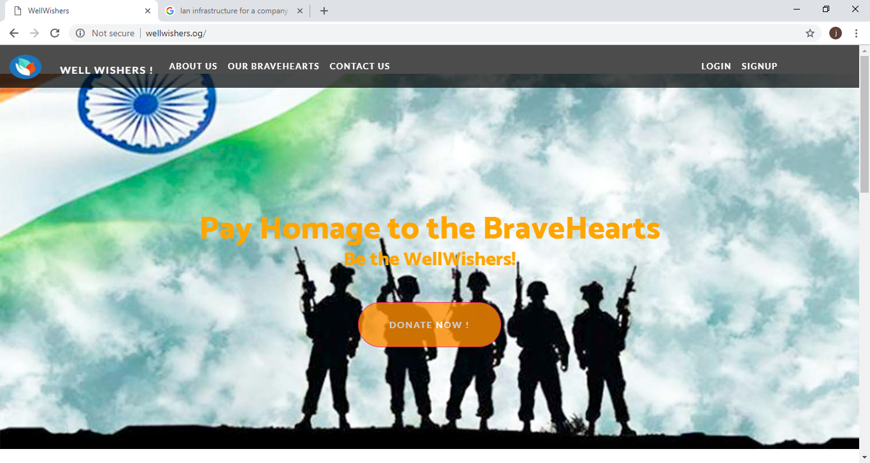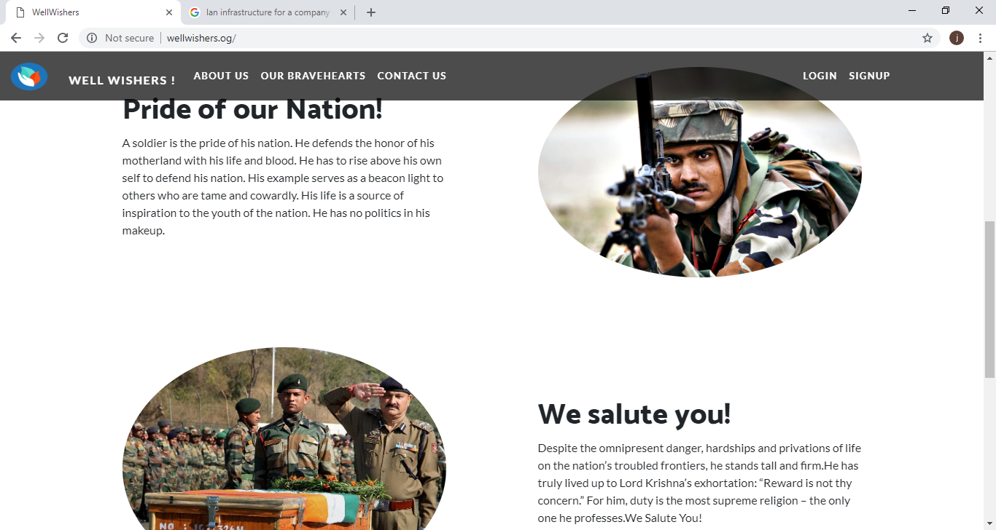

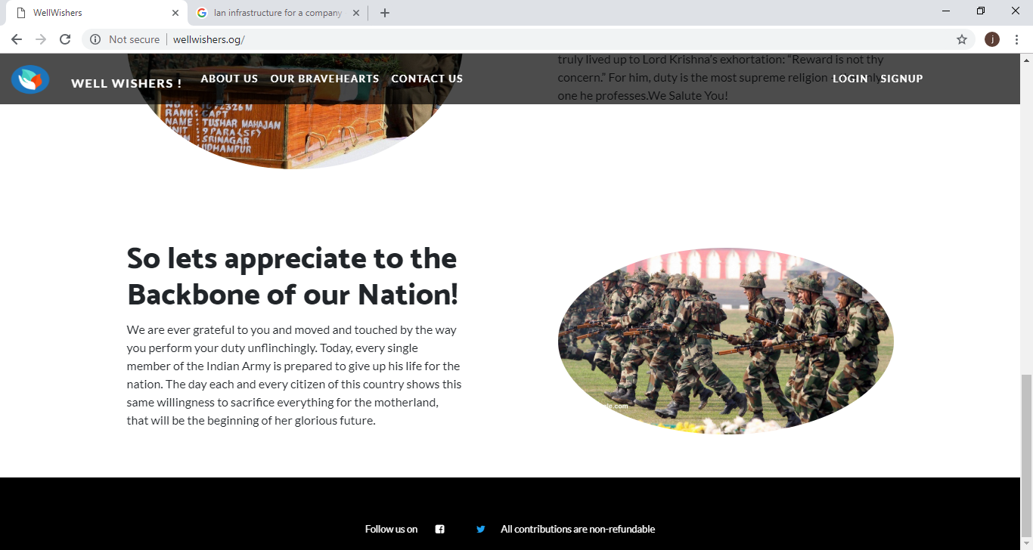

SignUp as new user

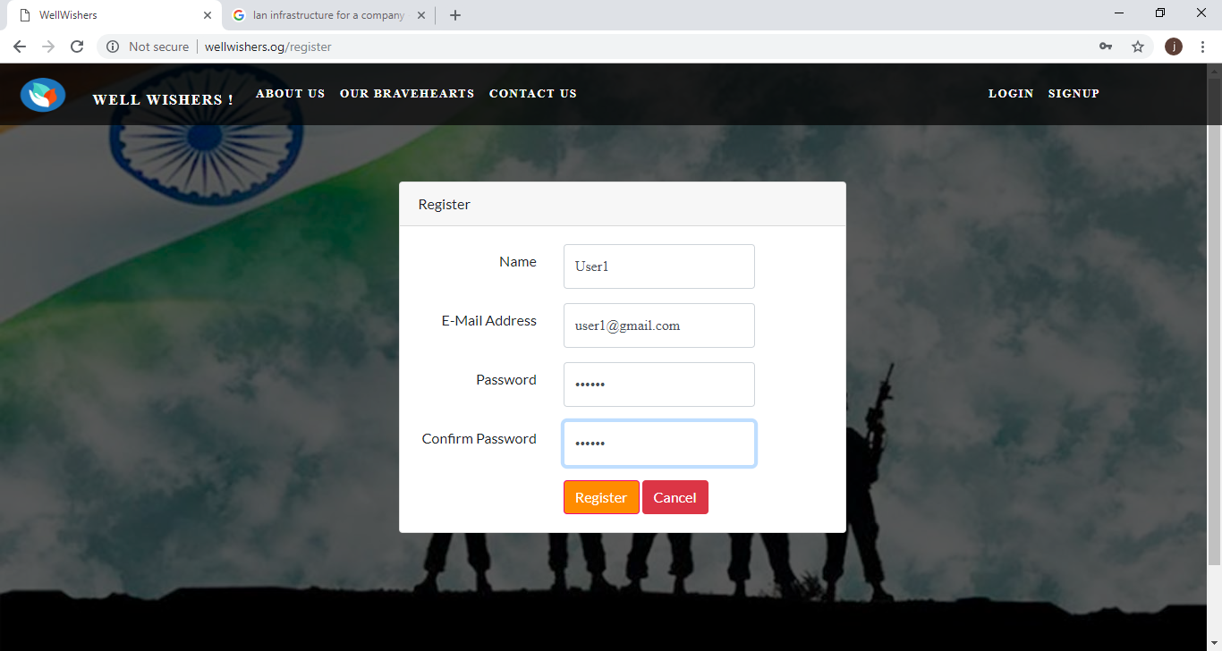

About Us

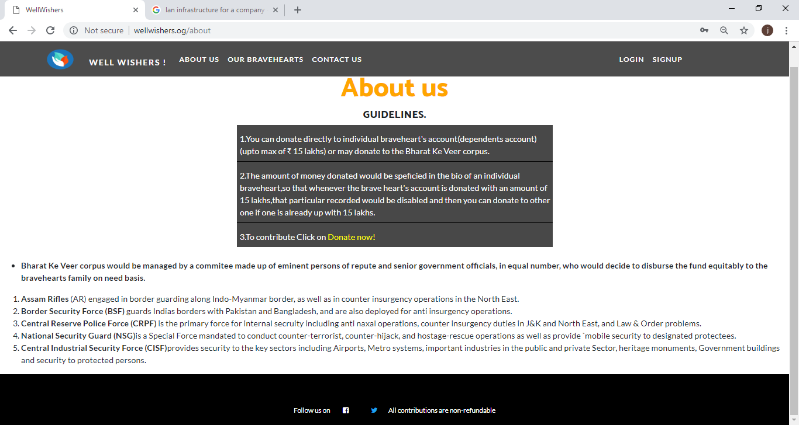

Contact Form

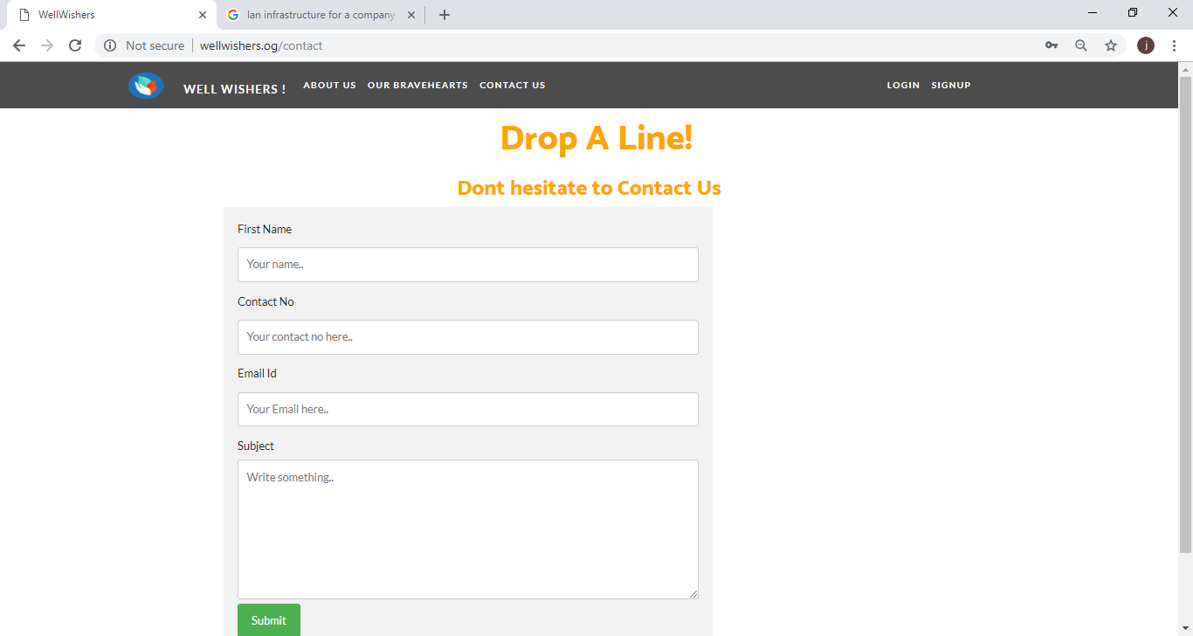

User Login

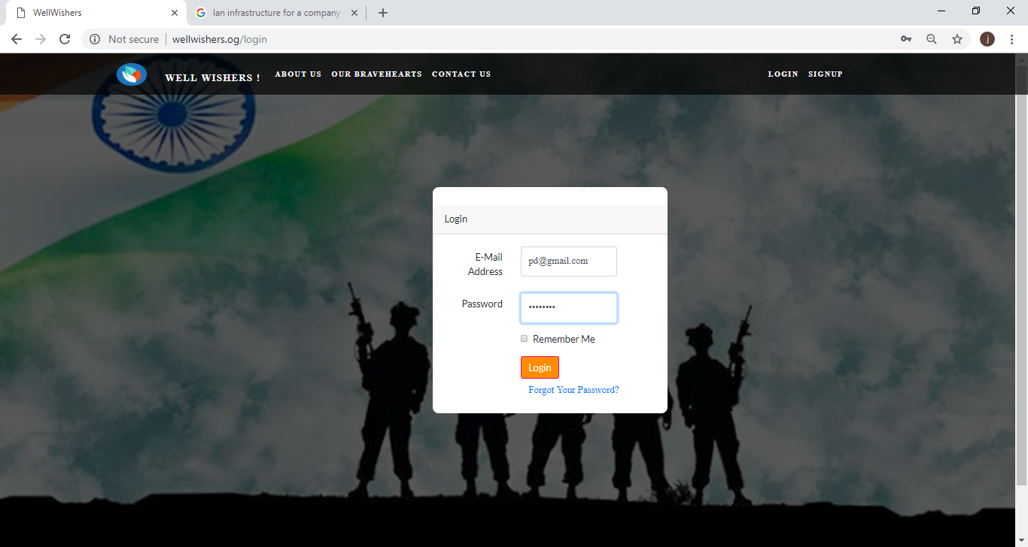

List of Soldiers as viewed by users

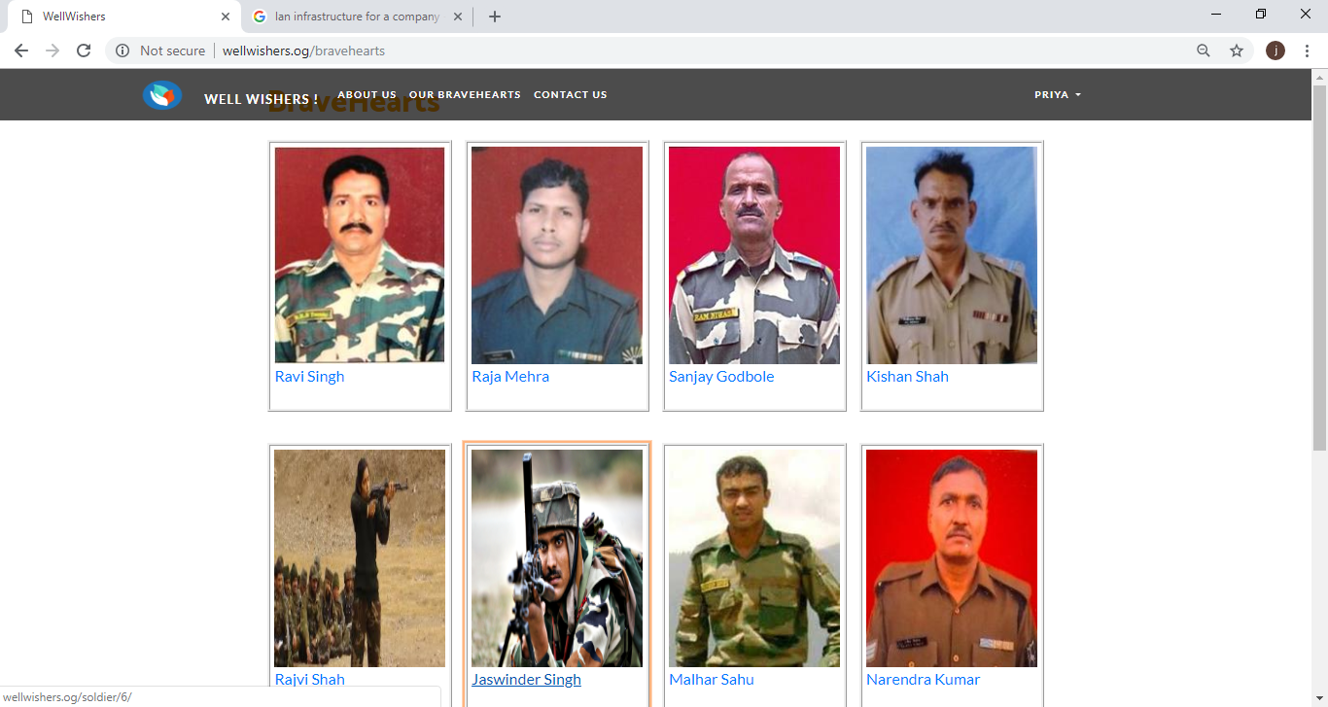

Soldier specific details

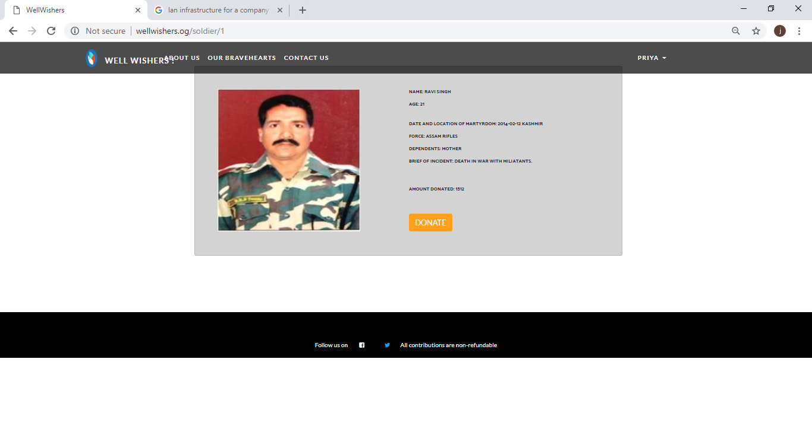

Redirect to donation page after clicking donate now

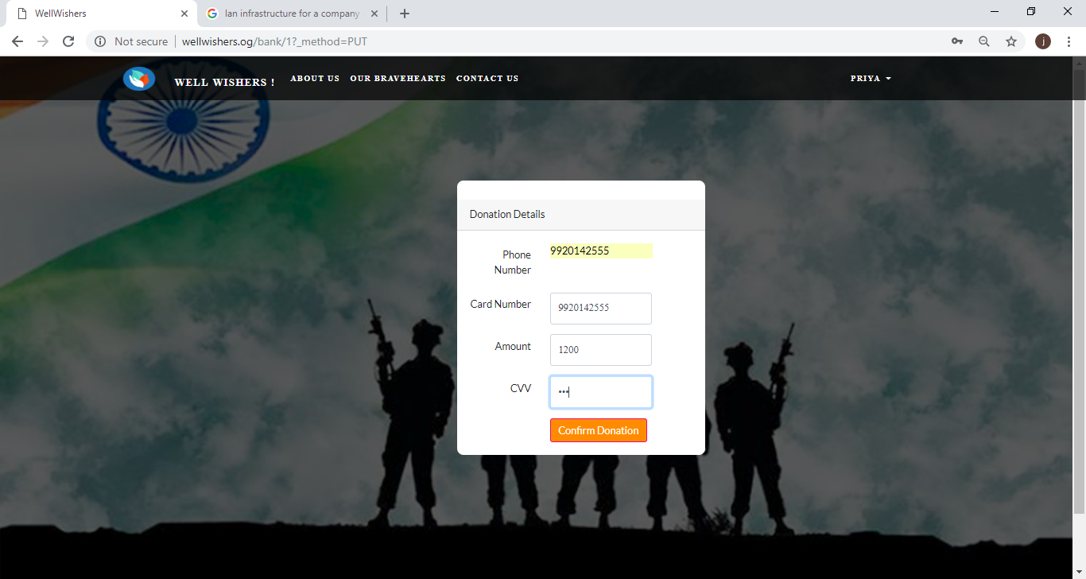

User views transactions in this fashion

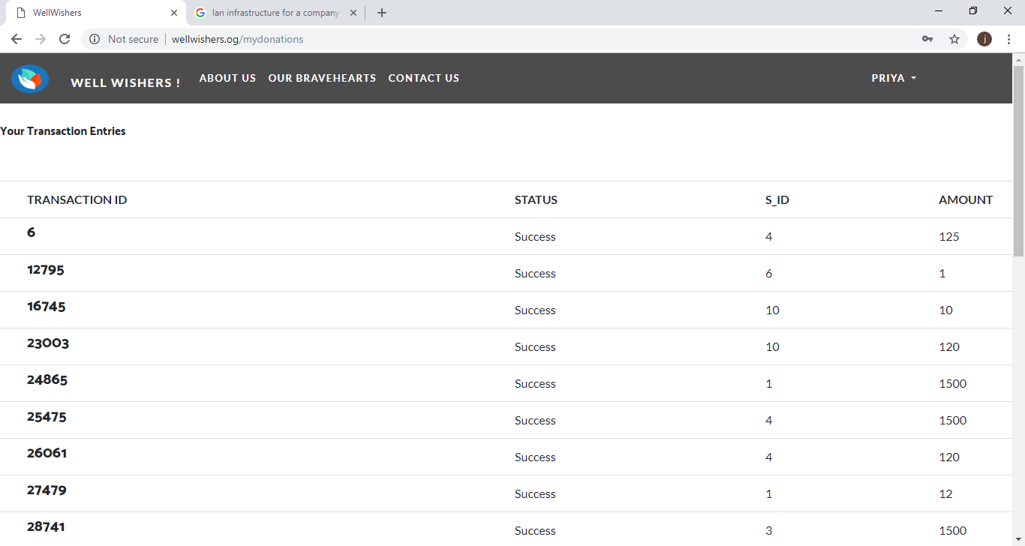

Admin Login

Admin Dashboard

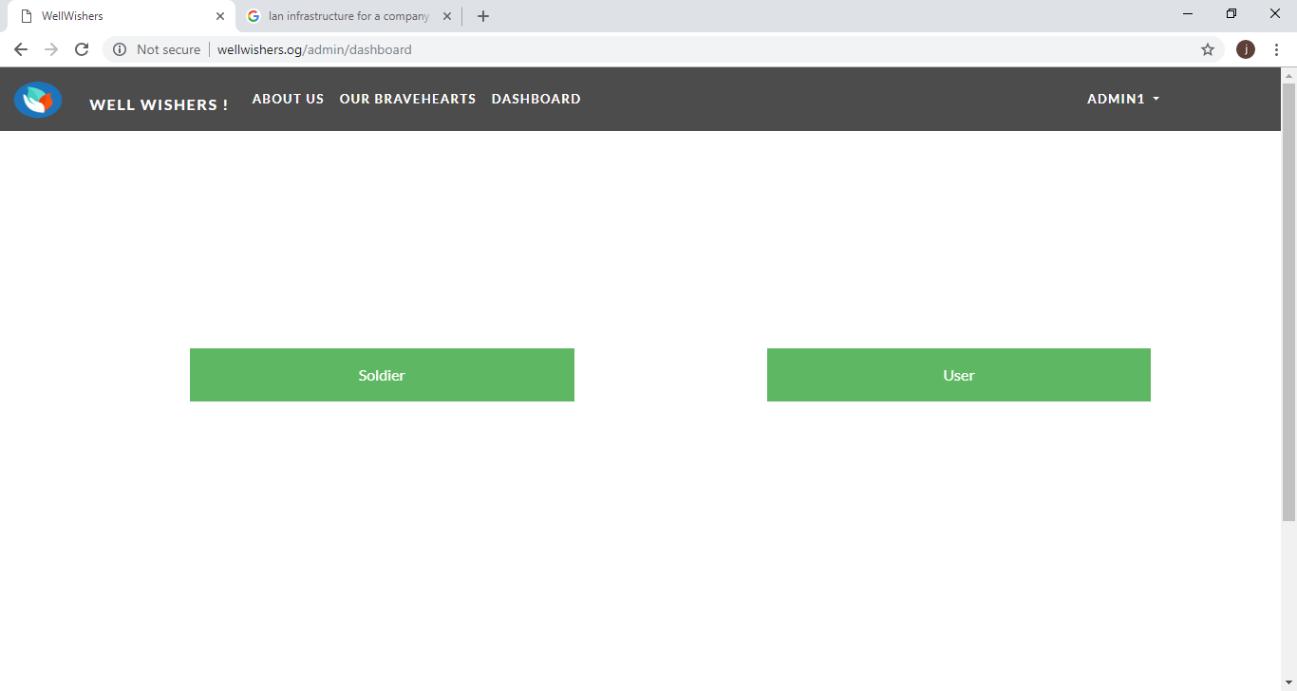

Soldiers for editing that are on the live website

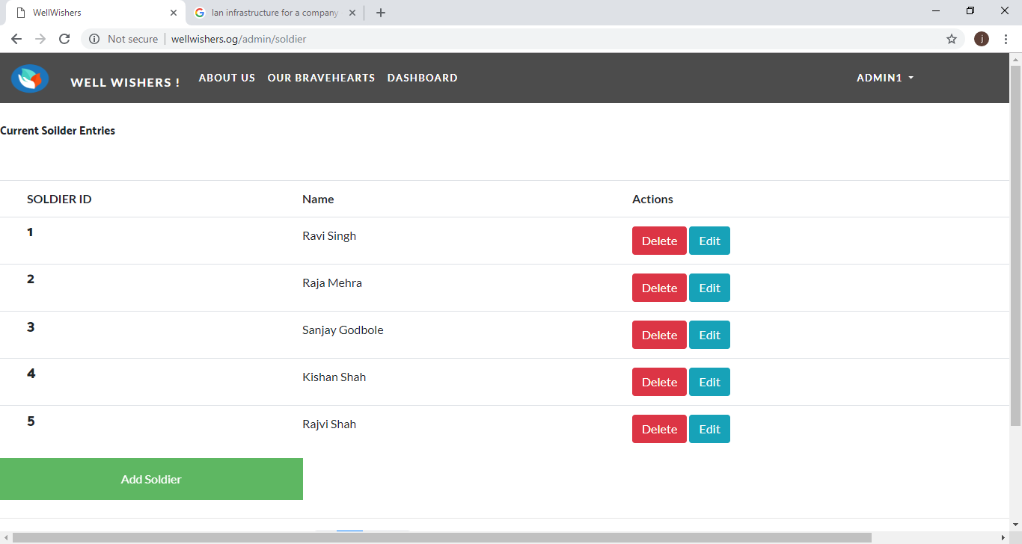

Admin can edit soldier details here

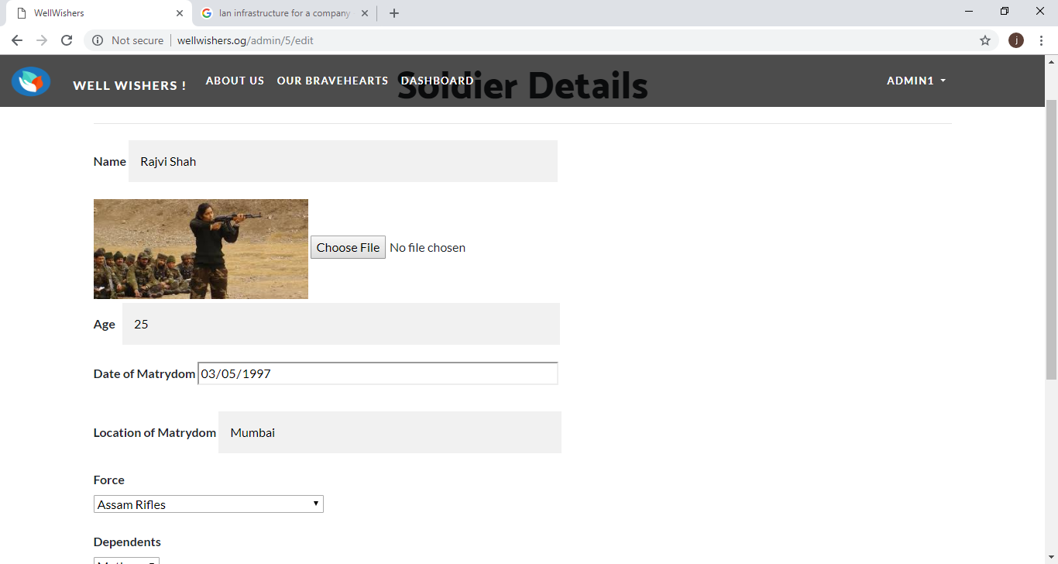

Admin adding a new soldier via a form

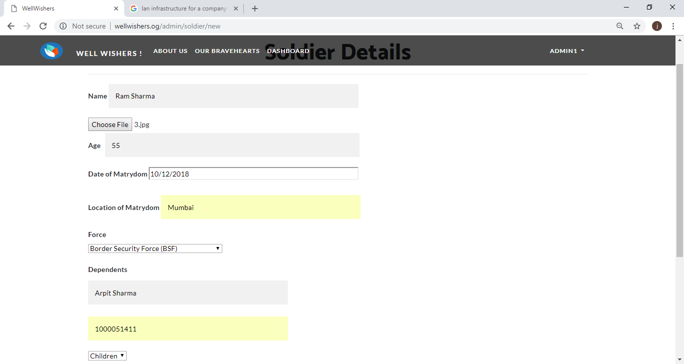

Admin can view users

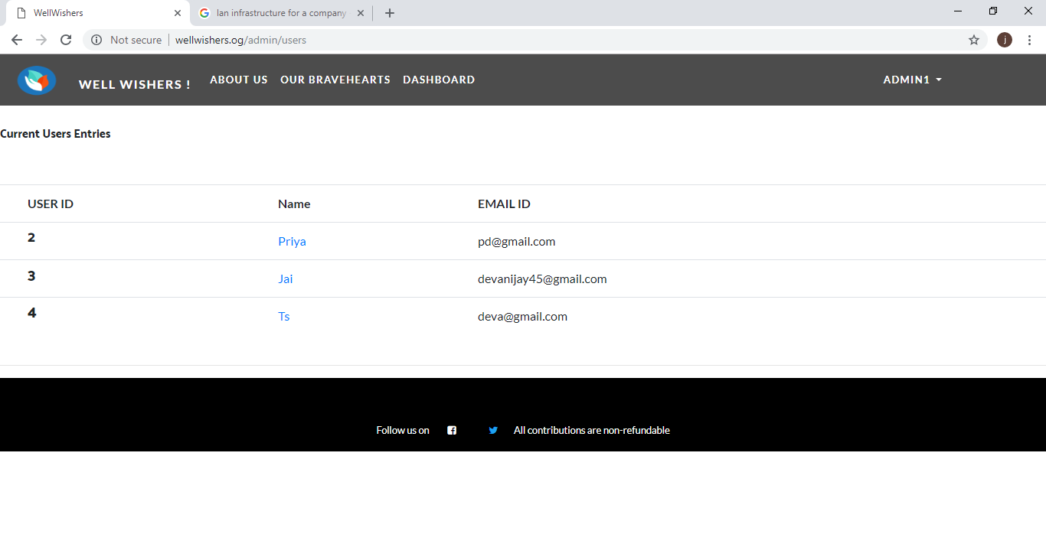

Admin views user specific transactions

